CS490 Windows Internals Labs
Sep 29th, 2011

- Watching Foreground Priority Boosts and Decays
Using the CPU Stress tool, you can watch priority boosts in action. It is a tool from Windows 2000 resource kit. You can find this tool in the CRK Tools package.
  - Open the System utility in Control Panel. Click the Advanced System Settings, and select the Advanced tab. Click the Settings button in the Performance section, and finally click the Advanced tab. Ensure that the Program option is selected (This value means that the priority value of the foreground thread will be boosted by 2).
  - Run CPUSTRES.exe and change the activity of thread 1 from Low to Busy.
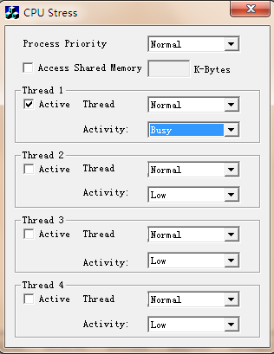
  - Start the Performance tool by selecting Administrative tools in Control Panel. Run Performance tool and click on the Performance Monitor entry under Monitoring Tools.
  - Click the Add Counter toolbar button to bring up the Add Counters dialog box.
  - Select the Thread object and then select the Priority Current counter.
  - In the instances box, select <All instances> and click Search. Scroll down until you see the CPUSTRES process. Select the second thread (CPUSTRES/1). (Notice that, CPUSTRES/0 is the GUI thread.) You should see something like this:
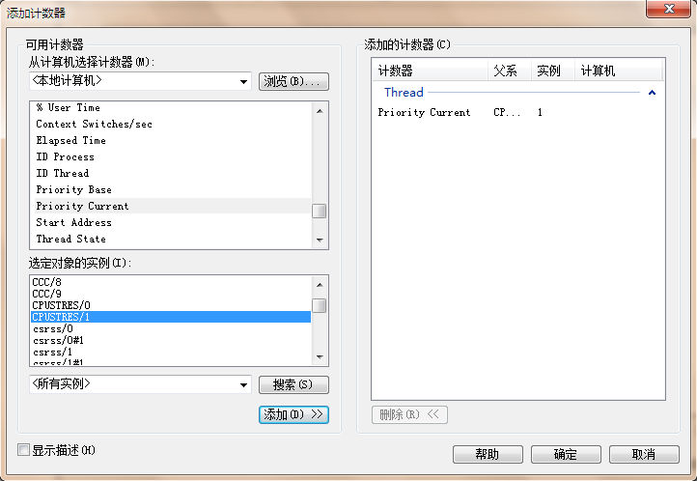
  - Click the Add button and then click OK.
  - Select Properties from the Action menu. Change the Vertical Scale Maximum to 16 and set the interval to Sample Every N seconds in the Graph area.
  - Now bring the CPUSTRES process to the foreground. You should see the priority of the CPUSTRES thread being boosted by 2 and then decaying back to base priority as follows:
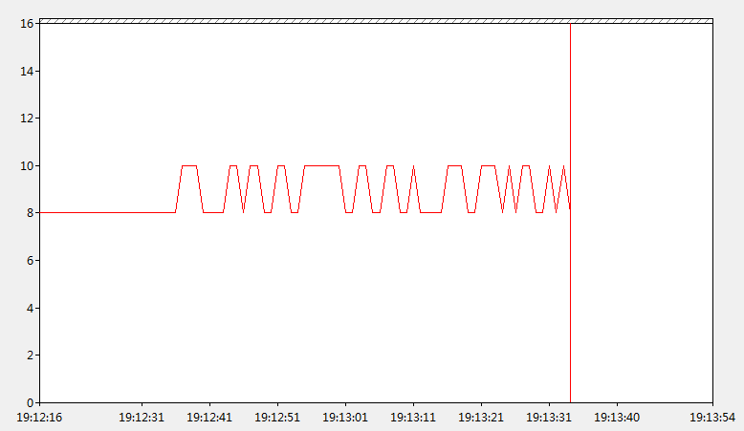
  - The reason CPUSTRES receives a boost of 2 periodically is because the thread you’re monitoring is sleeping about 25 percent of the time and then waking up (this is the Busy Activity Level). The boost is applied when the thread wakes up. If you set the Activity level to maximum, you won’t see any boosts because Maximum in CPUSTRES puts the thread into an infinite loop. Therefore, the thread doesn’t invoke any wait functions and as a result doesn’t receive any boosts.
  - When you’ve finished, exit Reliability and Performance Monitor and CPU Stress.

- Watching Priority Boosts for CPU Starvation
Using the CPU Stress tool (in the resource kit and the Platform SDK), you can watch priority boosts in action. In this experiment, we’ll see CPU usage change when a thread’s priority is boosted. Take the following steps:
- Run Cpustres.exe. Change the activity level of the active thread (by default, Thread 1) from Low to Maximum. Change the thread priority from Normal to Below Normal.
- Run the Performance Monitor.
- Click the Add Counter toolbar button (or press Ctrl+I) to bring up the Add Counter dialog box.
- Select the Thread object, and then select the % Processor Time counter.
- In the Instance box, scroll down the list until you see the cpustres process. Select the second thread (thread 1). (The first thread is the GUI thread.)
- Click the Add button, and then click the Done button.
- Raise the priority of Performance Monitor to real-time by running Task Manager, clicking the Processes tab, and selecting the Perfmon4.exe process. Right-click the process, selects Set Priority, and then selects Realtime.
- Run another copy of CPU Stress. In this copy, change the activity level of Thread 1 from Low to Maximum.
- Now switch back to Performance Monitor. You should see CPU activity every 6 or so seconds because the thread is boosted to priority 15.

- “Listening” to MMCSS Priority Boosting
In this experiment, we are going to check the priority boosting of MMCSS
  - Run Windows Media Player and begin playing some audio content.
  - If you have a multiprocessor machine, be sure to set the affinity of the Wmplayer.exe process so that it only runs on one CPU.
  - Start the Performance Monitor and add Counter.
  - Select the Thread object and then select the priority current.
  - In the Instances box, select <All instances>, and then click Search. Scroll down until you see Wmplayer, and then select all its threads. Click the Add button and click OK.
  - Change the Vertical Scale Maximum to 31 by selecting Action, properties and select graph tab.
  - You should see one or more priority 21 threads inside Wmplayer, which will be constantly running unless there is a higher-priority thread requiring the CPU after they are dropped to the Exhausted category (Priority 1-7).
  - Run CPUSTRES, and set the activity level of Thread 1 to Maximum, and raise the priority of Thread 1 from Normal to Time Critical.
  - You should notice the system slowing down considerably, but the music playback will continue. Every so often, you’ll be able to get back some responsiveness from the rest of the system. Use this time to stop CPUSTRES.
  - Notice that, MMCSS runs at priority 27, and it will lower some 21 priority threads to the Exhausted category (Priority 1-7), and then boost up again.

